Exp No. -5 .Create a simple cloud software application for product selling using any cloud service provider to demonstrate saas.
Done by: Juhi Surin Register no.: 192525148

Aim:
To develop a cloud-based Product Selling System using Zoho Creator (SaaS) to enable customers to purchase products online.

Procedure:
- Log in to Zoho Creator and create a new application named Product Selling System.
- Create a Product Order Form with customer and product details.
- Add fields for quantity, price per unit, and total amount.
- Create a workflow to calculate the total amount automatically.
- Add an On Success workflow to display an order confirmation message.
- Test the application by placing sample product orders.

Implementation Steps:
- Create the Product Selling System application in Zoho Creator.
- Design the Product Order Form with all required fields.
- Configure dropdowns, number, currency, and payment fields.
- Add Deluge workflows for total amount calculation and order confirmation.
- Enter sample order details and submit the form.
- Verify that the total amount is calculated correctly and the order is stored successfully.

Output:
- Form

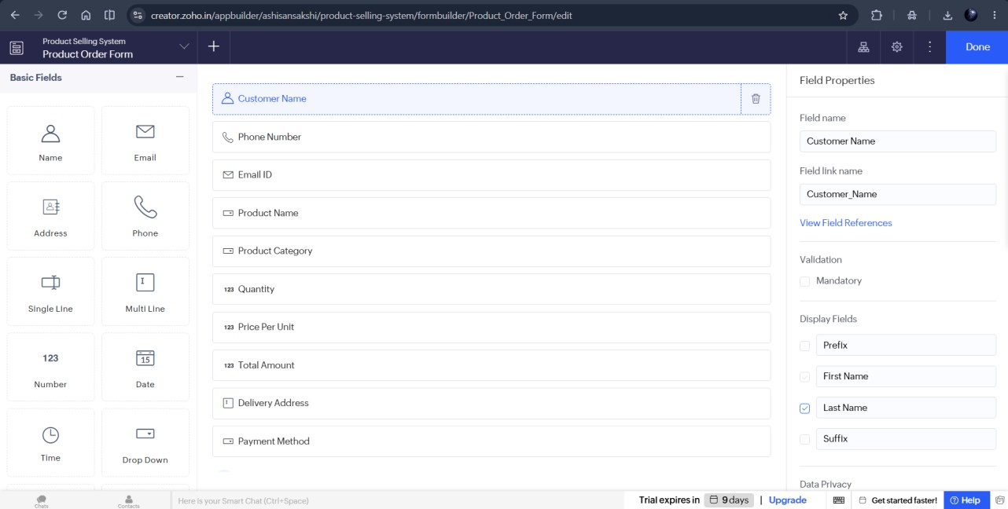

- Workflow
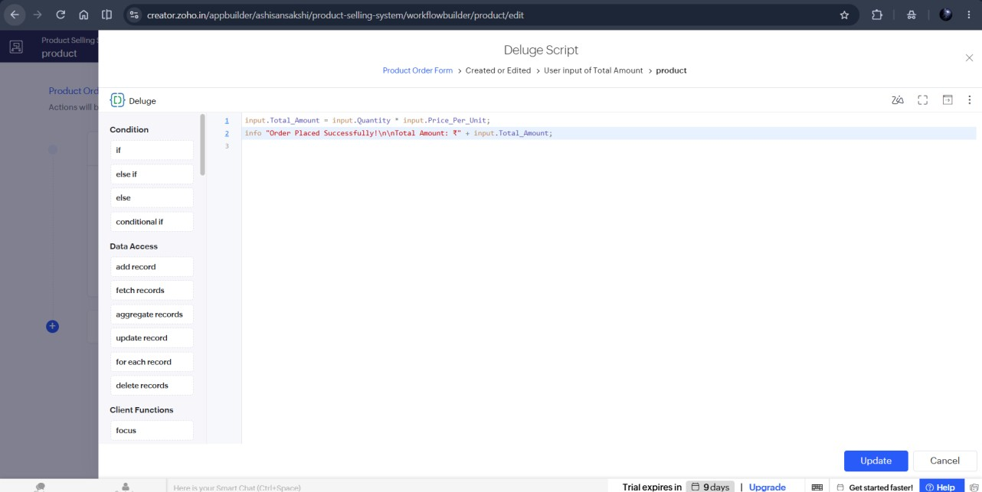

- Report
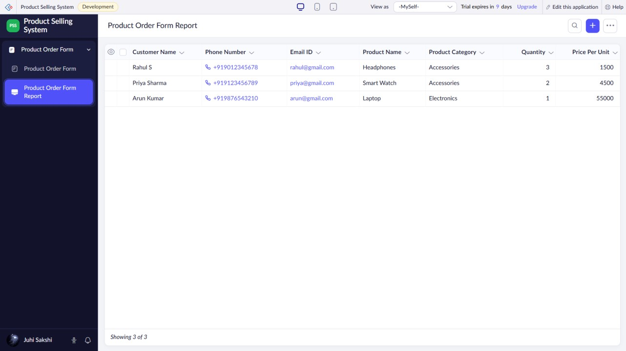

Result:
Thus, a cloud-based Product Selling System was successfully developed using Zoho Creator (SaaS), enabling customers to purchase products online with automatic total amount calculation and order confirmation.

